

Penrhos College
Semester 2 Examination, 2011

Question/Answer Booklet

MATHEMATICS SPECIALIST:
3C/3DMAS
Section Two:
Calculator-assumed

Student Name:____________________

Time allowed for this section

Reading time before commencing work: 10 minutes
Working time for section: 100 minutes

Material required/recommended for this section

To be provided by the supervisor
Question/answer booklet for Section Two. Candidates may use the removable formula sheet from Section One

To be provided by the candidate
Standard items: pens, pencils, pencil sharpener, highlighter, eraser, ruler
Special items: drawing instruments, templates, notes on up to two unfolded sheets of A4 paper, and up to three calculators, CAS, graphic or scientific, which satisfy the conditions set by the Curriculum Council for this course.

Important note to candidates
No other items may be taken into the examination room. It is your responsibility to ensure that you do not have any unauthorised notes or other items of a non-personal nature in the examination room. If you have any unauthorised material with you, hand it to the supervisor before reading any further.

Instructions to candidates
1. All questions should be attempted.

2. Write your answers in the spaces provided in this Question/Answer Booklet. Spare answer pages may be found at the end of this booklet. If you need to use them, indicate in the original answer space where the answer is continued (i.e. give the page number).

3. Show all your working clearly. Your working should be in sufficient detail to allow your answers to be checked readily and for marks to be awarded for reasoning. Incorrect answers given without supporting reasoning cannot be allocated any marks. For any question or part question worth more than two marks, valid working or justification is required. If you repeat an answer to any question, ensure that you cancel the answer you do not wish to have marked.

4. It is recommended that you do not use pencil except in diagrams.

Section Two: Calculator-assumed (80 Marks)

This section has twelve (12) questions. Answer all questions. Write your answers in the space provided.

Suggested working time for this section is 100 minutes.

Question 9 (4 marks)

Use proof by exhaustion to prove that 127 is a prime number.

Question 10 (9 marks)

The triangle ABC with vertices A(0, 0), B(3, 1) and C(-1, 2) is transformed by the matrix on to the triangle A'B'C'.

(a) Determine the coordinates of A' and C'.
[2]

(b) The area of triangle A'B'C' is 7 square units. What is the area of triangle ABC?
[2]

(c) Matrix M represents a combination of transformation X followed by transformation Y. If the matrix for transformation , determine the matrix for transformation Y and describe the geometric transformation Y represents.
[3]

(d) The triangle A'B'C' then undergoes a shear of factor parallel to the y-axis such that the image of the coordinate C' is (4, -3). Determine the value of.
[2]

Question 11 (6 marks)

The complex number satisfies the inequality .

(a) Show that
[3]

(b) Hence sketch the set of all complex numbers z that satisfy the inequality on the axes below.
[3]
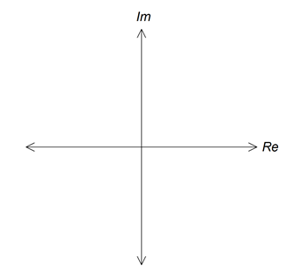

Question 12 (8 marks)

(a) According to research carried out by a company the proportion of households switching between oil, gas and electric heat in the United States after 1 year is shown in the table below.

 |  | To
 |  | Oil | Gas | Electric
From | Oil | 70% | 30% | 0
 | Gas | 10% | 80% | 10%
 | Electric | 20% | 0 | 80%

If the pattern of switching types of heating continues

(i) determine the proportion of current households using gas who will be using gas in 5 years time.
[2]

(ii) determine in the long term what proportion, to the nearest percent, of
households will be using each of the three forms of heating?
[2]

(b) A farmer is breeding marron in one of his dams. He has collected the following data on their breeding and survival rates in 2003.

Age (years) | 1 | 2 | 3 | 4
Population | 750 | 1200 | 900 | 600
Birth Rate | 0 | 0.7 | 1.4 | 0.5
Survival Rate | 0.7 | 0.6 | 0.5 | 0

- Construct a Leslie matrix, L, to represent this population.
[1]

- What is the total population in 2009?
[1]

(iii) Over a period of time the population growth reaches a steady state of 6.5%. If in the long term the farmer wishes to maintain a stable population level in the dam what culling rate of each age group will the farmer need to set?
[2]

Question 13 (6 marks)

The velocity of a particle that travels in a straight line is given by , where v is in m/s and t is in seconds.

(a) Determine the times when the particle is at rest.
[2]

(b) If the particle was initially at the origin determine an expression for its displacement.
[2]

(c) Determine the distance the particle travelled in the third second.
[2]
Question 14 (5 marks)
The diagram below shows parallelogram ABCD where and .
Point X divides DB internally in the ratio 2:1.
Point M is the midpoint of AB.
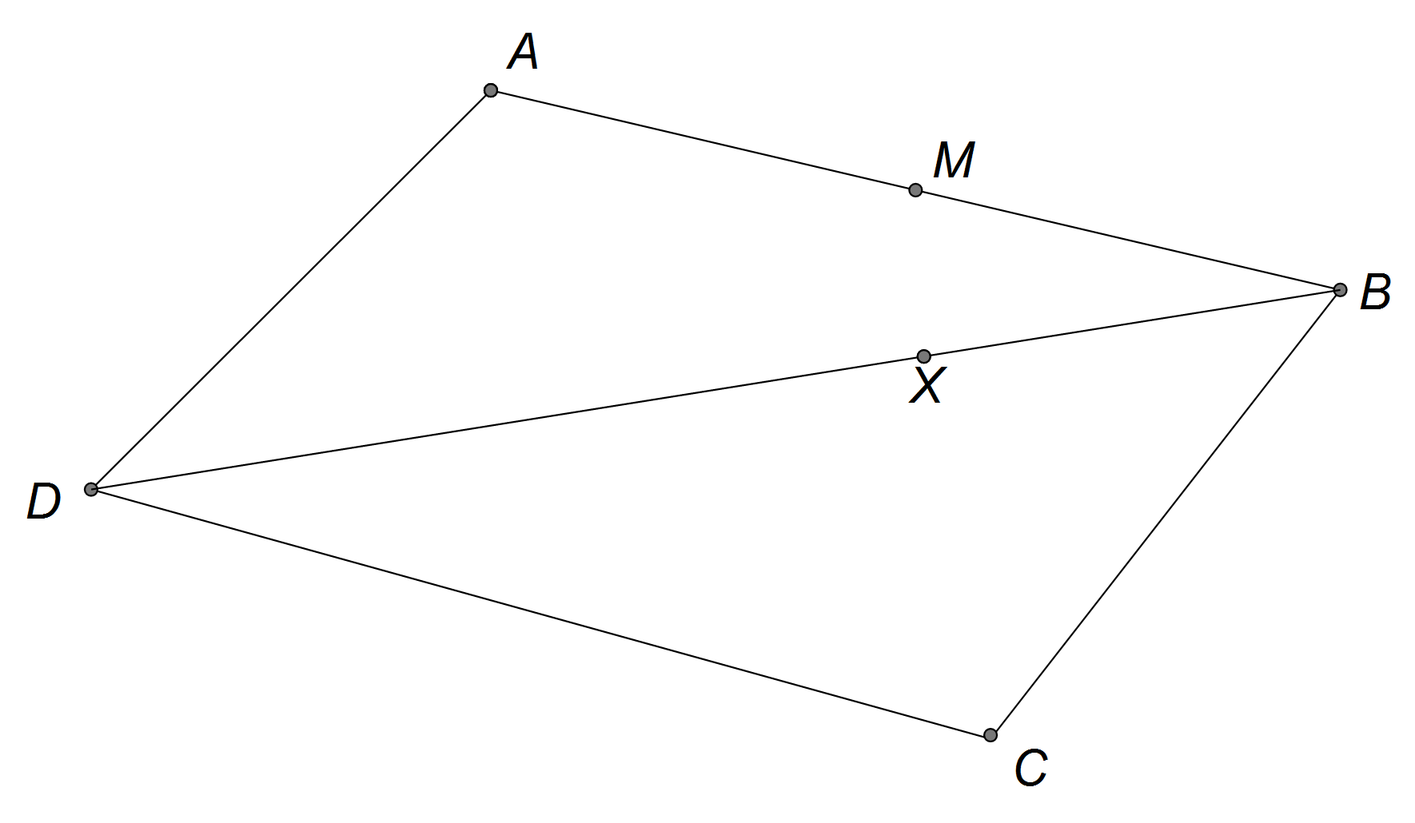

(a) Show that
[1]

(b) Find in terms of a and b.
[1]

(c) Prove that points M, X and C are collinear.
[3]

Question 15 (5 marks)

A certain type of electronic circuit will remain in a stable state if the values of two variable resistors, x and y, satisfy the equation .
In a particular circuit, the value of y is increasing at a rate of 15 units per second. At what rate must x be changing when y = 1000 for the circuit to remain stable?

Question 16 (6 marks)

A line and a plane are given by and .

(a) Given that the point (2, c, -2) lies on the plane determine c.
[2]

(b) Find the position vector of the intersection between the line and the plane.
[2]

(c) Find the acute angle between the line and the plane.
[2]

Question 17 (6 marks)

The graph of is shown below
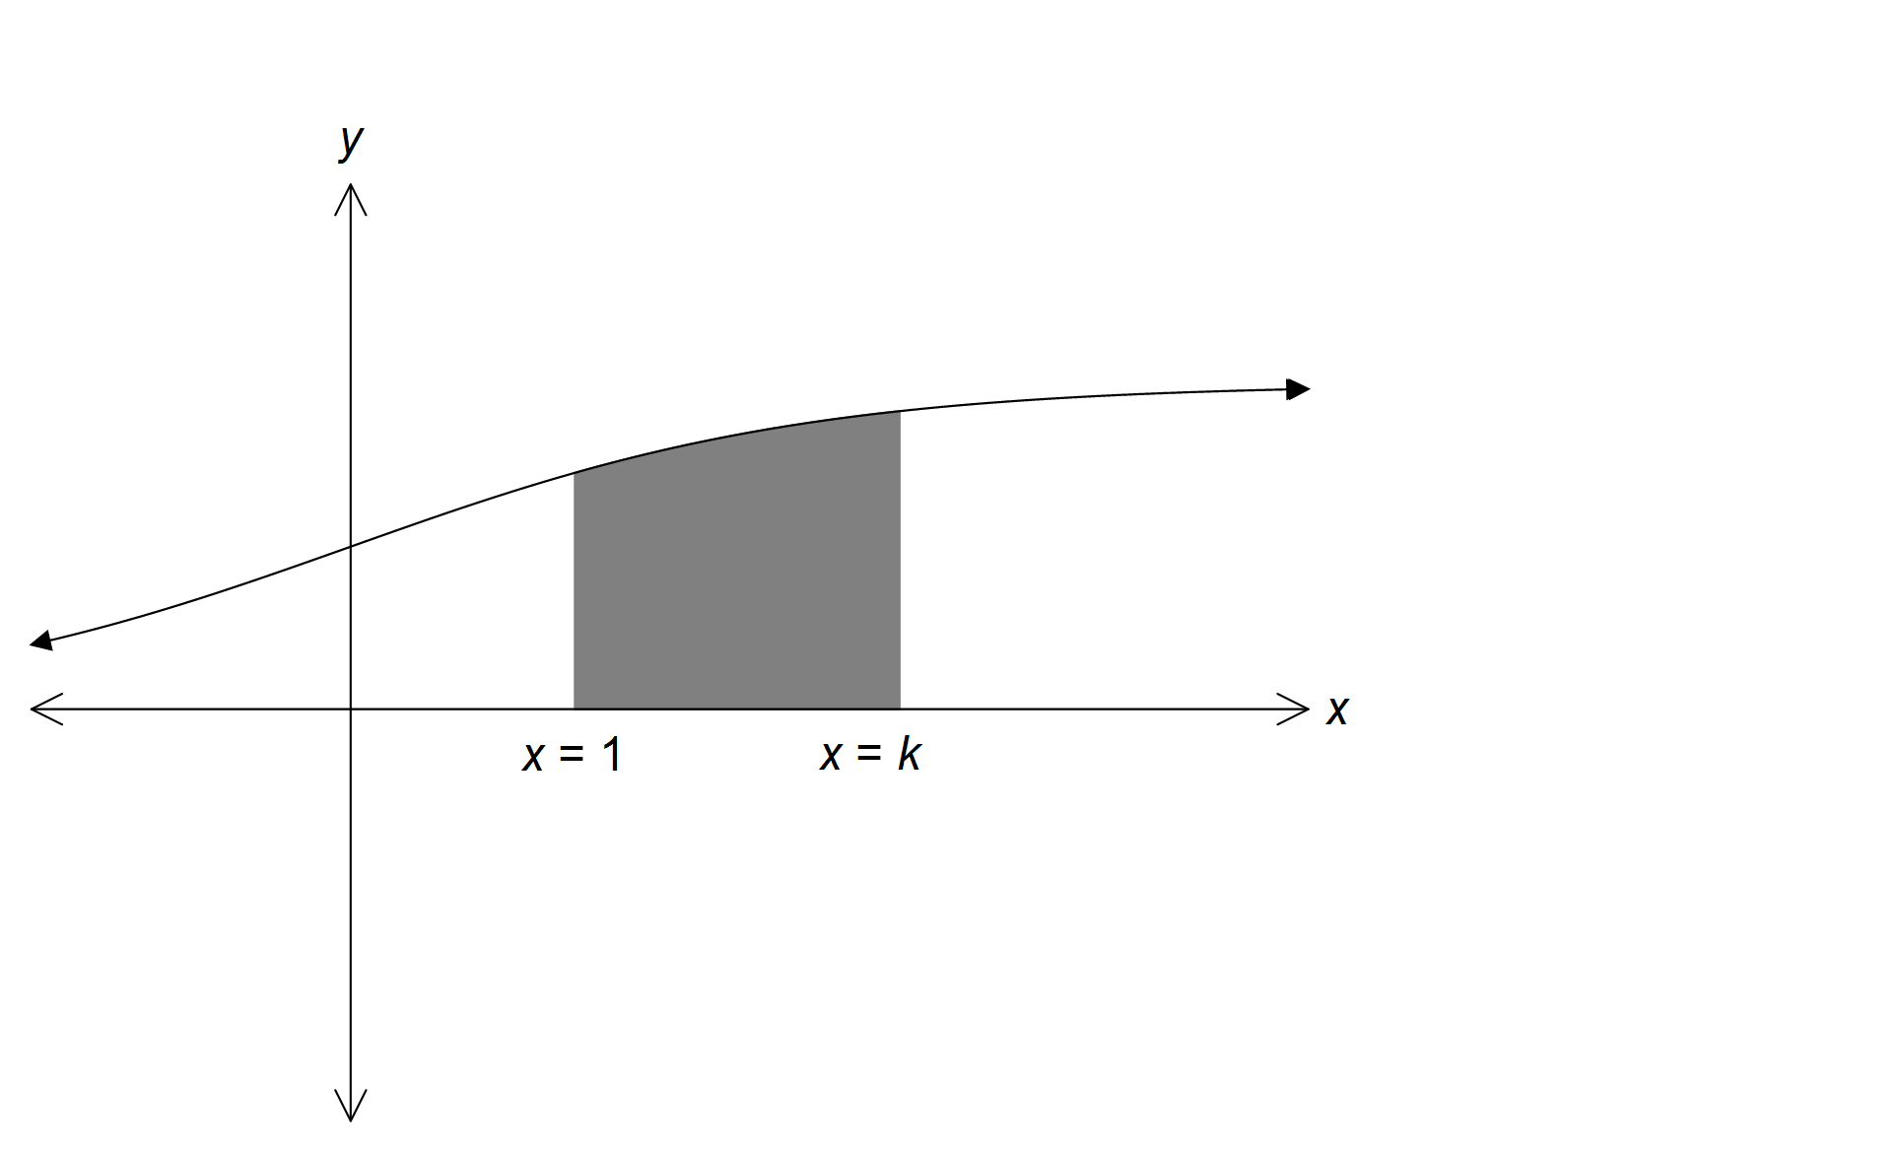

(a) Show that the area enclosed between the curve f(x) and the x-axis between x = 1
and x = k, is .
[3]

(b) The graphs of f(x) and are shown below. Determine the area bound by the two curves and the line x = 2.

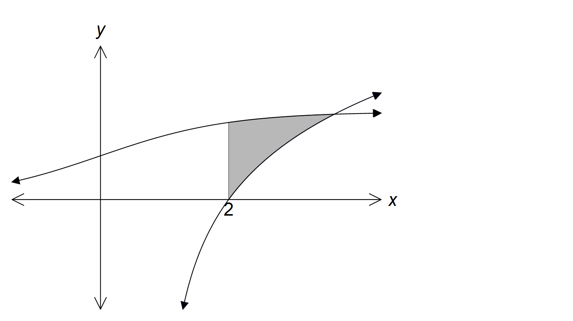

[3]

Question 18 (10 marks)

An object, P, has an initial position of metres and is moving with a constant velocity of metres per second.

(a) A second object, Q, is moving with constant velocity of metres per second and collides with object P after six seconds.

Determine the initial distance apart of object P and object Q.
[4]

(b) A third object, R, is initially located at metres and is also moving with a constant velocity metres per second. Determine the value of x such that after 5 seconds the distance between objects P and R is minimised. State the minimum distance at this time.

[6]

Question 19 (5 marks)

The solution to the differential equation passes through the point where x = 0 and y = 2. Determine y when x = 1.

Question 20 (10 marks)

(a) One of the solutions to the equation is shown on the graph below.

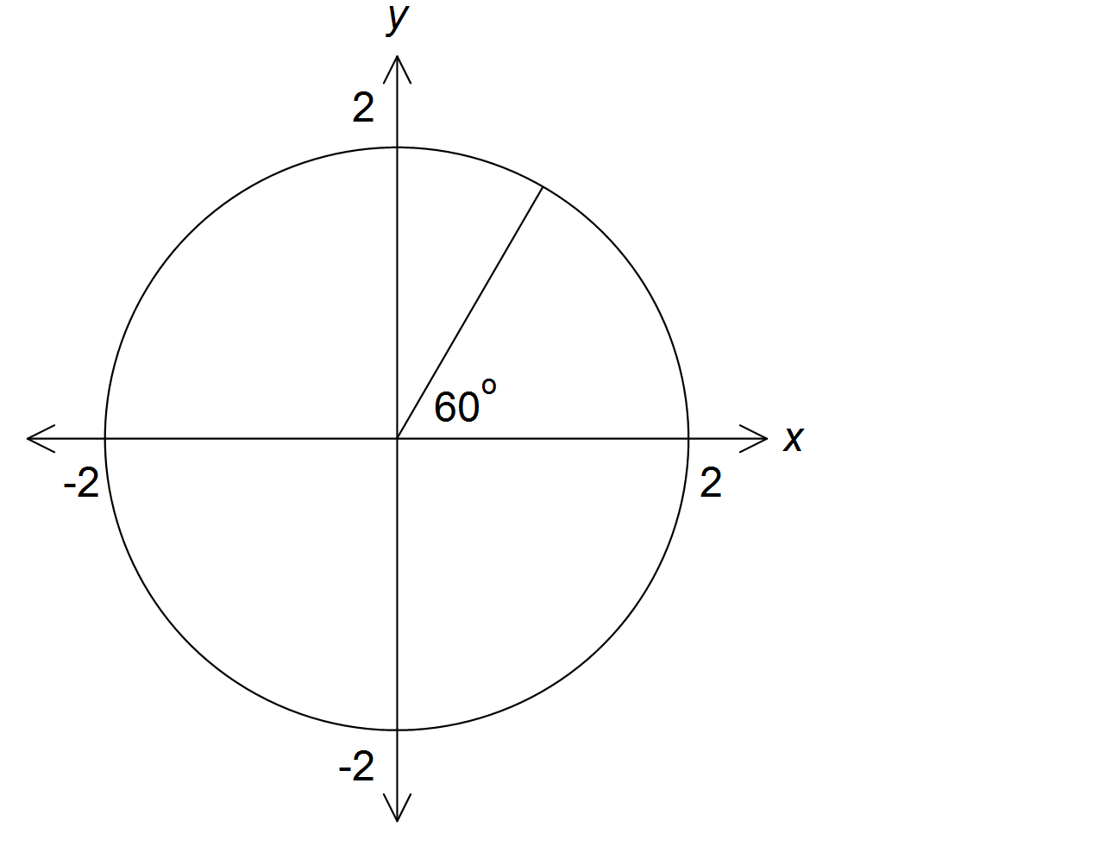

(i) Make a sketch of the remaining roots on the axes above.
[1]

(ii) Determine algebraically the value of k in Cartesian form.
[2]

(b) (i) Solve algebraically, using de Moivre’s theorem giving your answers
in Cartesian form.
[5]

(ii) Hence, solve algebraically.
[2]

Additional working space

Question number(s):

Additional working space

Question number(s):

